Linux - Lab #5

File and Directory Management

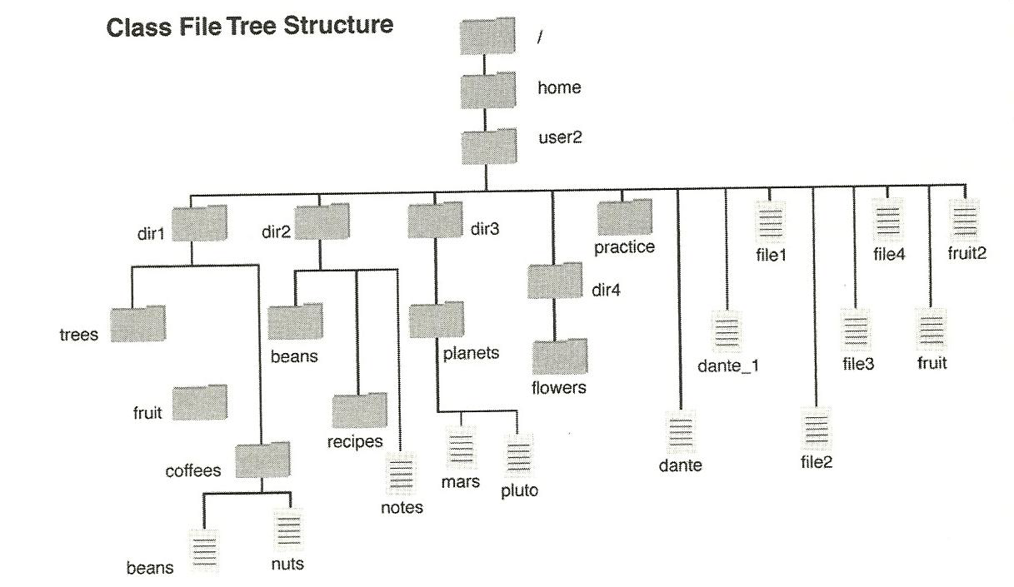

# Task 1

Create a user account called user2. Then create the above tree structure under user2’s home directory.

# Task 2

Install and use the tree command to show the final file structure.